A07-whatever CRUD UX

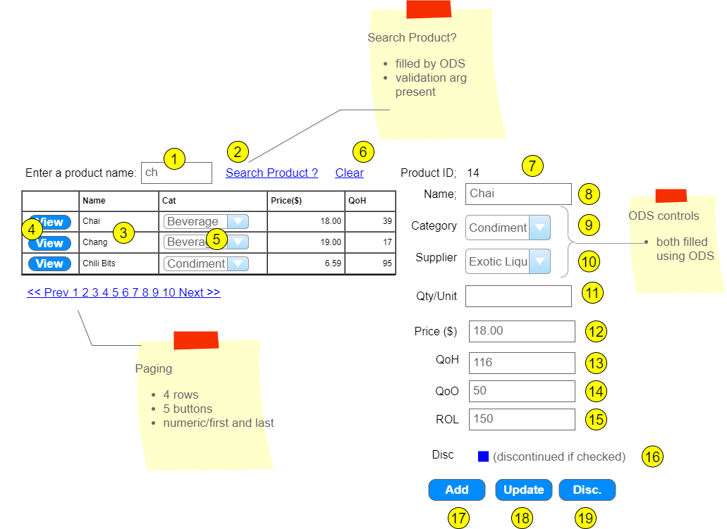

|  |  |  |  |  |  |
| --- | --- | --- | --- | --- | --- |
|  | Control Name | Load/Use | CRUD | Validation | Event actions / Notes |
| 1 | ProductArg | -/2 | R | presence | Input to Search button  Validate using code-behind |
| 2 | SearchProduct | -/3 | R | CausesValidation false | Wired ODS to GridView  Uses ProductArg as input  **List<Product> Product_FindByPartialName(string)** |
| 3 | ProductList | 2/4 | R |  | Empty Data message  ODS loaded  Dropdownlist load is ODS  Button uses hidden productid to fill details fields |
| 4 | Select command | -/7-10 | R | CausesValidation false | Use hidden productid on row to load detail fields  **Product Product_Find(int)** |
| 5 | CategoryGVList | 2/- | R |  | ODS filled  **List<Category> Category_List()** |
| 6 | Clear | -/1,3,7-18 |  |  | Clear form  Reset 9,10 to None |
| 7 | ProductID | 4/17,18 | U,D |  | Read-Only |
| 8 | ProductName | 4/17,18 | C,U | presence |  |
| 9 | CategoryList | 4/17,18 | C,U |  | Nullable  Loaded using ODS  **List<Category> Category_List()**  Requires a None option |
| 10 | SupplierList | 4/17,18 | C,U |  | Nullable  Loaded using ODS  **List<Supplier> Supplier_List()**  Requires a None option |
| 11 | QuantityPerUnit | 4/17,18 | C,U |  | Nullable |
| 12 | UnitPrice | 4/17,18 | C,U | >= 0.00 | Nullable |
| 13 | UnitsInStock | 4/17,18 | C,U | >=0 | Nullable, max Int16 |
| 14 | UnitsOnOrder | 4/17,18 | C,U | >=0 | Nullable, max Int16 |
| 15 | ReorderLevel | 4/17,18 | C,U | >=0 | Nullable, max Int16 |
| 16 | Discontinued | 4/18 | U |  |  |
| 17 | Add | -/8-16 | C |  | Collect fields 8 thru 16  Load to entity instance  **Int Product_Add(Product)**  Return new product id  Refresh 7  appropriate msg |
| 18 | Update | -/7-16 | U |  | Collect fields 7 thru 16  Productid must be present  Load to entity instance  **Int Product_Update(Product)**  Return rows affected  Use for appropriate msg |
| 19 | Disc | -/7,16 | U | CausesValidation false | Get productid (7)  Productid must be present  **Int Product_Discontinue(int)**  Set discontinued to true and update  Return rows affected  Use for appropriate msg  Set checkbox on (16) |